Telanagana State Industrial Project Approval & Self Certification System (TS-iPASS)

DIC Login Incentive Module
USER MANUAL
Prepared by



FRUX Software Solutions Pvt. Ltd.,
Flat 401, SVP Residency, Lane: 5,
Balaji Nagar, Nizampet, Hyderabad,
Telangana-500090.

Login Screen:

Login Screen
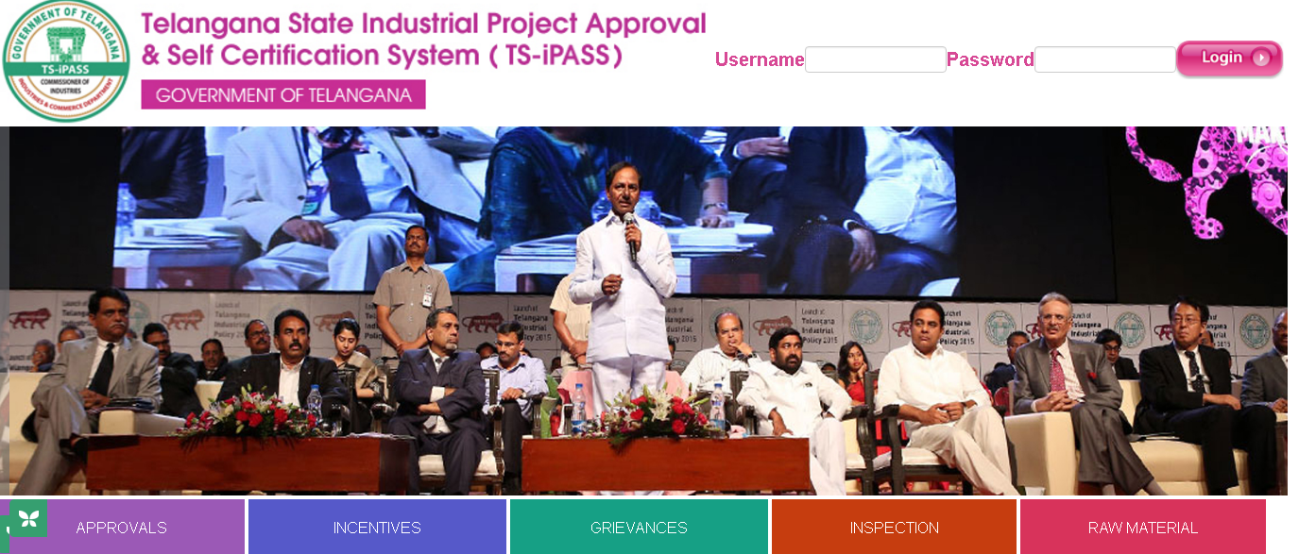
Screen Description:

This screen is used to Authenticate and Authorize for accessing and using different features and functionalities in Telanagana State Industrial Project Approval & Self Certification System (TS-iPASS). You can Login to the application by providing your User Credentials like User Name and Password.
Sl. No | Input Type | Description | Mandatory (Yes/No/NA)
1 | User Name | Enter the User name | Yes
2 | Password | Enter the Password | Yes
3 | Login | Click on Login button to log into the MIS | Yes
4 | Cancel | Click on Cancel to clear the columns in the Login Page | NA

Work flow of DIC in Incentive Module:

Forwarding the incentive applications to the Inspecting Officers IPOs / ADs under him for inspections

Approving / Rejecting the Incentive applications at DIC level depending upon the Inspection report uploaded by IPOs / Ads

Uploading GM certificate for the approved incentive applications

Forwarding the approved applications to Collector / Commissioner of Industries for further process.

Incentives Menu
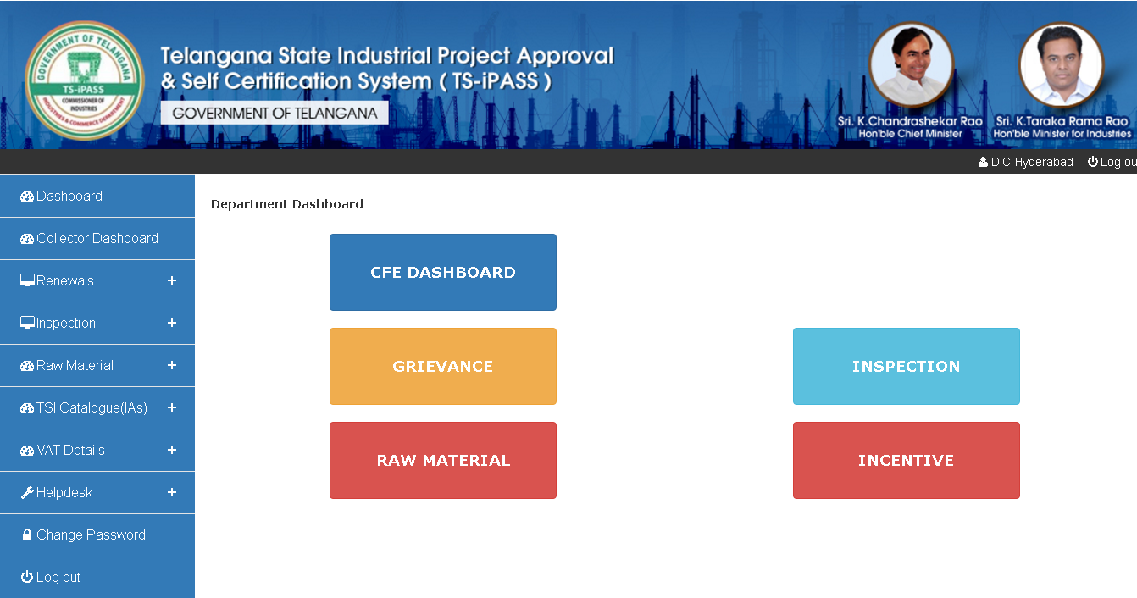
Screen Description: When you click on Incentives under Dashboard below screen will be displayed.

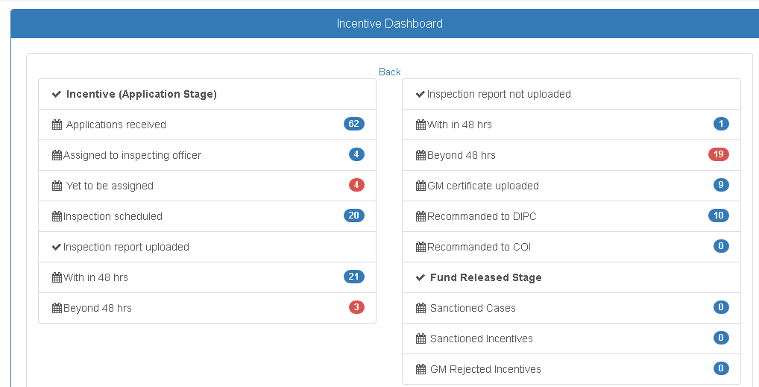
When you click on Yet to be assigned option in the above login, below screen will be displayed:

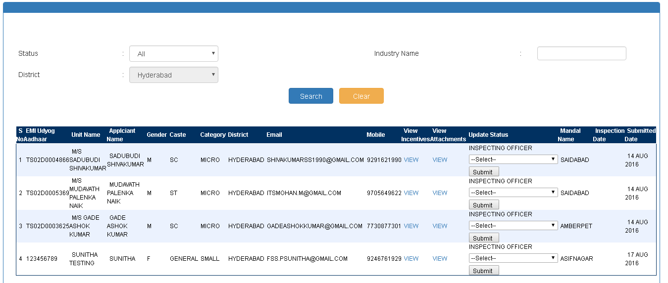
Screen Description: Incentive applications applied by the entrepreneurs will be forwarded to the concern DICs. DIC can log in to the MIS and forward the applications for inspections to IPOs / Ads under him. For forwarding the applications DIC needs to select the Inspecting officer from the dropdown and click on submit. That application will be forwarded to concerned IPO / AD.

Incentive application will be forwarded to the concerned Inspecting Officer. Once they schedule the inspection and uploaded the inspection report it will again forwarded to DIC for further process. DIC need to check the application forwarded by IPO / AD under below screen:
When you click on above respective link, below screen will be dispalyed. Using this screen DIC can Approve / Reject the incentive application depending upon the Inspection report uploaded by IPO / AD, upload the GM certificates for the approved applications and forward same to Collector / Commissioner of Industries for further process.
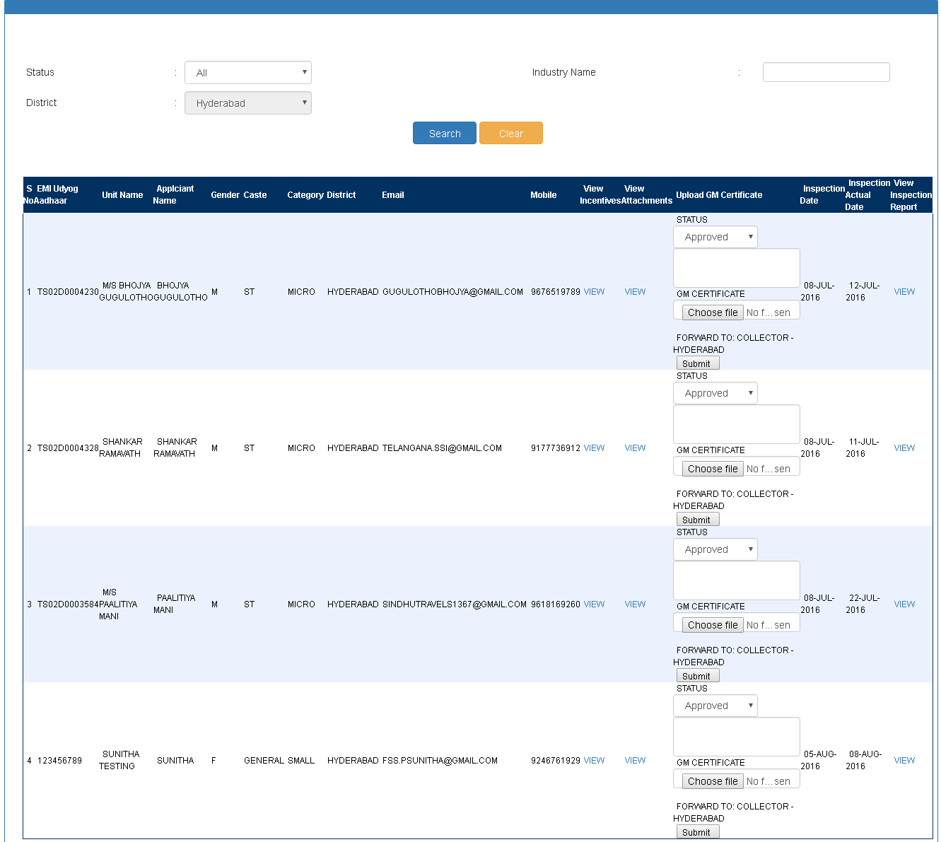

****** Thank You ******

